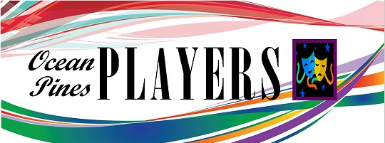
Board of Directors Meeting Agenda
May 10, 2021, 6:00 pm, Community Center
- Call to Order Establish Quorum
- Accept Meeting Minutes from April 13, 2022 – Frank/Karen
- Treasurer report – Karen
- Nominations and election of vacant board positions
  - Secretary
  - Board Member
  - Board Member

Necessary Business
- Board Member/Committee Reports
- Lighting Proposal
- Website/FB update - Cara
- Big Bad Musical Cancellation Update - Frank
  - Reimbursement
  - Grant issue
- Happy Birthday USA - Karen
  - Audition Dates
  - Performance Dates
  - Performance venue
  - Ticket Prices
- Grand Night for Singing Update – Frank
  - Yacht Club deposit paid
  - Need to pay R&H for rights
  - Need to Order scripts
  - Need Audition Dates
- Cabaret (Love Actually) Update – Karen
  - Audition Dates
  - Performance Dates
  - Performance Venue
- Play On!
  - Need to pay Concord for rights
  - Need to Order scripts
  - Need Audition Dates
- Need show for next May
  - Play reading/suggestion committee
  - Director selection committee

Old Business before the Board
- Strategic Planning Meeting
- New Ticket Platform, Frank
- Women substance series, museum collaborations, Pat D
- New email address
- Any other New Business
- New logo

New Business:

Next meeting, Tuesday, June 14, 2022 @ 6pm

REMINDER: any BOD member may request an item to be added to the agenda for any meeting by simply notifying the President of that wish.

New Business:
5. New logo - If we don't have time for a full discussion, let's appoint a committee to hash out 1. What's our mission statement?, 2. how do we open to and accept submissions? 3. how many versions will make it to a BOD vote? 4. what's our timeline for a decision?
6?. Do we need a special election now that we've lost 2 Bd members?

