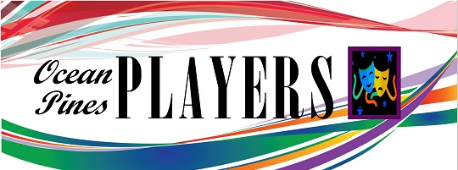
Board of Directors Meeting Agenda
April 13, 2021, 6:00 pm, Atlantic Hotel, Berlin
- Call to Order Establish Quorum
- Accept Meeting Minutes from March 23, 2022 – Frank/Karen
- Treasurer report - Karen

Necessary Business
- Board Member/Committee Reports
- Big Bad Musical Cancellation Update - Frank
  - reimbursement
- Snow Hill Showboat (Possible Cancellation) - Karen
- Grand Night for Singing Update – Frank
  - Yacht Club deposit required
- Cabaret Update – Karen
- Play On!
- Need show for next May
  - Play reading/suggestion committee
  - Director selection committee

Old Business before the Board
- Review Committee structure and members
  - Structure
  - Members
- New Ticket Platform, Frank
- Women substance series, museum collaborations, Pat D

New Business:
- Website (new URL), Cara
- Ticketing Platform, Frank
- New email address
- Any other New Business
- New logo

Next meeting, Tuesday, May 10, 2022 @ 6pm

REMINDER: any BOD member may request an item to be added to the agenda for any meeting by simply notifying the President of that wish.

